CampusFix
Smart Campus Complaint & Maintenance Tracker
Project Report
Course: Software Engineering
Instructor: Sir Jahanzaib Ahmed Khan

Group Members:
Muhammad Azam (IU05-0124-0190)
Kashif Raza (IU05-0124-0303)
Tehreem Aijaz (IU05-0124-0126)

Abstract
CampusFix is a desktop-based campus complaint and maintenance tracker created for a Software Engineering course project. The system focuses on one common university problem: students and staff often report maintenance issues informally, and those issues can be forgotten because there is no simple tracking flow. CampusFix provides a small but complete GUI application where users can submit complaints and administrators can assign, prioritize and close them. The project is implemented in Python using Tkinter for the graphical interface and SQLite for persistent local storage.

1. Introduction
In a campus environment, complaints about electricity, plumbing, classroom furniture, IT equipment, cleanliness and safety need a proper recording process. The aim of this project is not to build a large enterprise helpdesk, but to create a practical academic system that demonstrates requirements engineering, database design, GUI development, testing and documentation.

1.1 Project Objectives
- Provide a simple complaint submission process for students and staff.
- Allow administrators to view, filter, assign and update complaints.
- Maintain complaint history with timestamps and current status.
- Show dashboard statistics that support quick decision making.
- Keep the design moderate enough to explain in a class presentation and viva.

1.2 Team Details
Member | Roll Number | Main Responsibility
Muhammad Azam | IU05-0124-0190 | Database design, testing support and documentation review
Kashif Raza | IU05-0124-0303 | GUI design, requirements analysis and final integration
Tehreem Ijaz | IU05-0124-0126 | SRS preparation, use cases and report formatting

2. Problem Statement
Manual complaint handling creates delays because complaints may be shared verbally, through WhatsApp messages or on paper. These methods do not provide a clear record of who submitted the complaint, where the issue is located, what priority it has, and whether the maintenance team has resolved it. CampusFix solves this by turning the complaint process into a small structured workflow.

3. Proposed Solution
The proposed system is a Python desktop application with two main roles: User and Admin. A user can register, log in, submit a complaint and view personal complaints. An admin can log in, see all complaints, search/filter records and update complaint status, assigned person and notes. SQLite is used as the local database because it is lightweight and easy to demonstrate on any laptop.

4. Technology Stack
Layer | Technology | Reason
Programming Language | Python | Readable syntax and suitable for quick GUI/database development.
GUI Framework | Tkinter | Built into Python, so the project runs without heavy external setup.
Database | SQLite | Lightweight file-based database, good for academic desktop applications.
Testing | unittest | Used to validate main database operations without extra dependencies.
Architecture | Layered desktop architecture | Separates interface code from database operations for maintainability.

5. SDLC Model Used
The project follows an Iterative and Incremental Model. In this model, the system is developed in small working parts instead of waiting until the end to test everything. CampusFix was divided into increments such as database setup, authentication, complaint submission, admin dashboard, search/filtering and testing.

5.1 Why This Model Was Used
- The project requirements were understandable, but the GUI needed small improvements after testing each screen.
- It allowed the team to create a working version early and then improve it step by step.
- Each module could be tested separately, especially database functions and role-based workflows.
- It fits a semester project because progress can be shown in milestones rather than only at the final stage.

6. Scope
The scope includes registration, login, complaint creation, complaint listing, admin filtering, status updates, assignment, notes and dashboard statistics. The current version is designed for a single campus and local desktop use. Online hosting, email notifications, mobile application support and file attachments are outside the current scope and are listed as future enhancements.

7. Functional Requirements
ID | Requirement | Description
FR-01 | User Registration | The system shall allow new student/staff users to create an account with name, email and password.
FR-02 | Login | The system shall authenticate users and open the correct dashboard based on role.
FR-03 | Submit Complaint | A user shall submit a complaint with title, category, location, priority and description.
FR-04 | Track Complaints | A user shall view his or her complaint history and current status.
FR-05 | Admin View | An admin shall view all submitted complaints in one dashboard.
FR-06 | Search and Filter | An admin shall filter complaints by status and search by title, reporter, category or complaint ID.
FR-07 | Assign Complaint | An admin shall assign a complaint to a staff member or technician.
FR-08 | Update Status | An admin shall update the status as Submitted, Assigned, In Progress, Resolved or Closed.
FR-09 | Dashboard Counts | The system shall display total, open, resolved and urgent complaint counts.

8. Non-Functional Requirements
ID | Attribute | Description
NFR-01 | Usability | The interface should be simple enough for a first-time user to submit a complaint without training.
NFR-02 | Reliability | SQLite foreign keys and required fields should protect the basic consistency of complaint records.
NFR-03 | Performance | Common dashboard operations should respond quickly for a small campus dataset.
NFR-04 | Maintainability | The code should keep GUI, configuration and database functions separate.
NFR-05 | Security | Passwords are not stored directly; the project stores SHA-256 password hashes for demonstration.

9. System Diagrams

9.1 Use Case Diagram
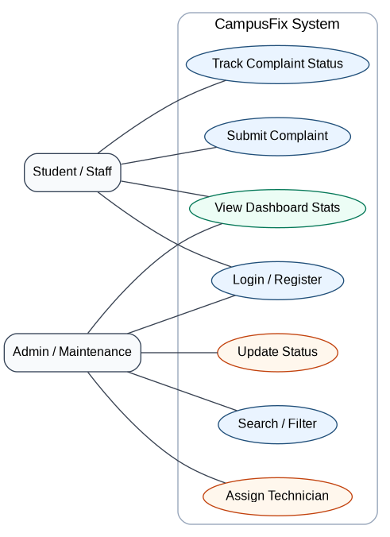
Figure 1: Main actors and use cases of CampusFix.

9.2 Class Diagram
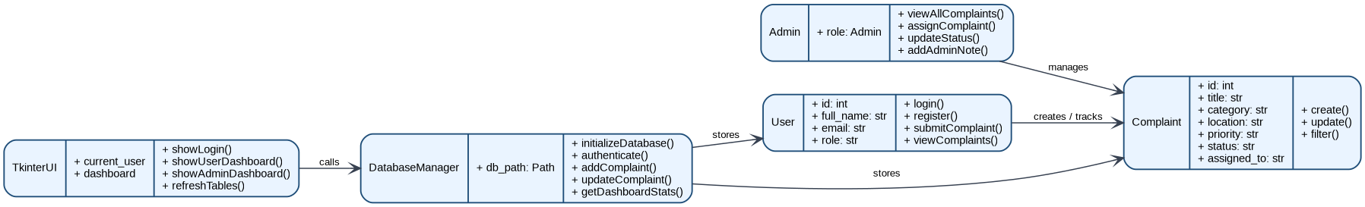
Figure 2: Main classes/modules and their responsibilities.

9.3 Activity Diagram
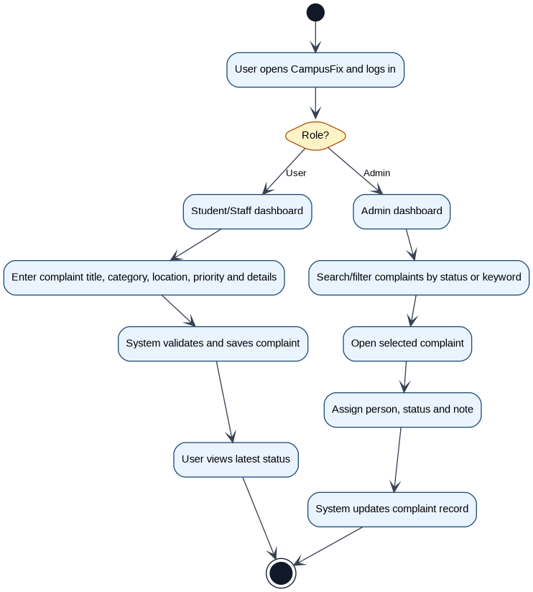
Figure 3: Complaint workflow for user and admin paths.

9.4 Sequence Diagram
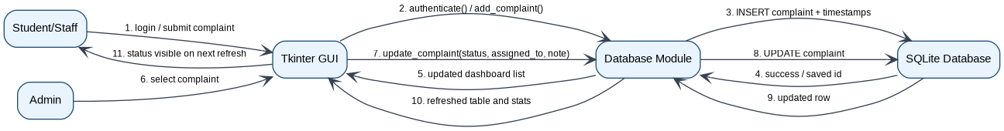
Figure 4: Sequence of complaint submission and admin update.

9.5 UML Component Diagram
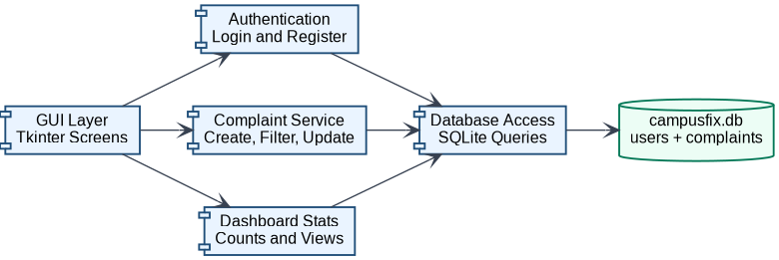
Figure 5: UML component view showing GUI, services and database layer.

9.6 Entity Relationship Diagram (ERD)
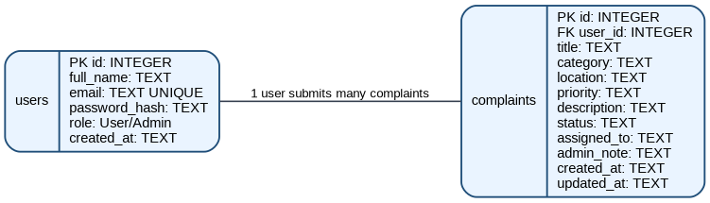
Figure 6: Database relationship between users and complaints.

10. Database Design
Table | Important Fields | Purpose
users | id, full_name, email, password_hash, role, created_at | Stores login accounts and user roles.
complaints | id, user_id, title, category, location, priority, description, status, assigned_to, admin_note, created_at, updated_at | Stores complaint records and admin progress updates.

The complaints table has a foreign key user_id that connects each complaint with the user who submitted it. This design keeps the database simple while still supporting the most important reporting and tracking operations.

11. System Features

Login and Registration
The system supports role-based login. The default admin and demo student accounts make classroom demonstration easier.

User Dashboard
Users can add complaints and view complaint status in a table with latest timestamps.

Admin Dashboard
Admins can search, filter, assign and update complaints without directly editing the database.

Dashboard Statistics
The application shows total, open, resolved and urgent counts to make complaint load visible.

Local Persistence
All records are stored in campusfix.db, so the application retains data after closing.

12. User Interface Screens
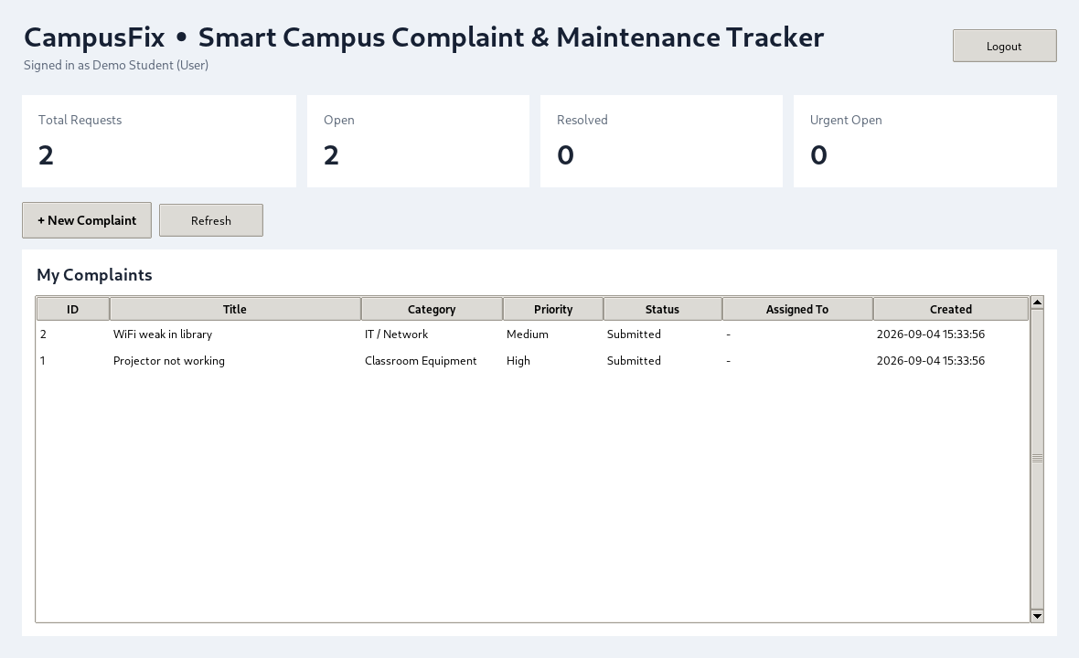
Figure 7: User dashboard for submitting and tracking complaints.
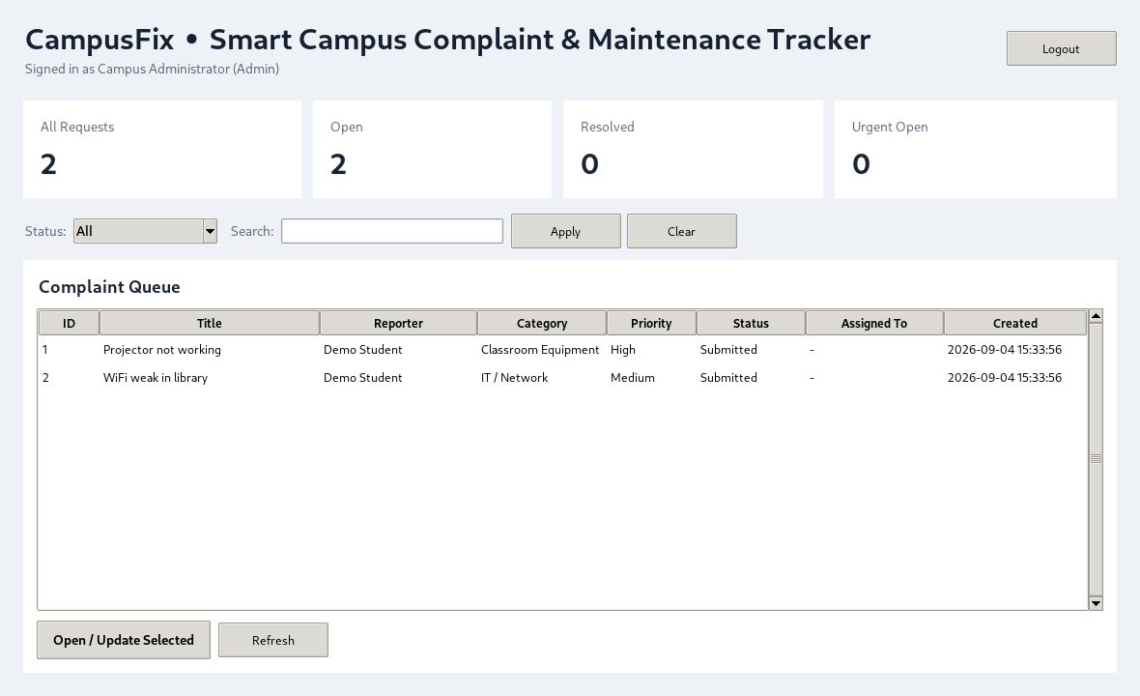
Figure 8: Admin dashboard for filtering and updating complaint records.

13. Testing
Test Case | Input / Action | Expected Result | Status
TC-01 | Login with valid default admin account | Admin dashboard opens | Pass
TC-02 | Register a new user with unique email | User account is created | Pass
TC-03 | Submit a complaint with required values | Complaint ID is created and saved | Pass
TC-04 | Filter complaints by status | Only matching complaints are shown | Pass
TC-05 | Update status and assigned person | Complaint record shows new status and note | Pass
TC-06 | Dashboard count after complaint update | Statistics refresh correctly | Pass

Automated database tests were also included to check registration, authentication, complaint creation, status update and dashboard statistics. This makes the project easier to verify during development.

14. Limitations
- The current version is a desktop application, not a web-hosted system.
- No email or SMS notification module is implemented.
- No image attachment feature is included for complaint evidence.
- The admin role is seeded for demonstration rather than managed through a full user management screen.

15. Future Enhancements
- Add photo attachments for complaints.
- Add email notifications when status changes.
- Add a web dashboard using Flask or Django.
- Add monthly reports for complaint categories and response time.
- Add technician login so assigned staff can update their own tasks.

16. Conclusion
CampusFix is a compact but complete Software Engineering project. It shows how a real campus problem can be converted into requirements, diagrams, database tables, a working GUI and test cases. The system is intentionally not overcomplicated, which makes it suitable for explanation in a class presentation and viva.

